COMP4541 Blockchain Project Report

Chung Ka Wai

20857033

Quantum Lottery: A Decentralized Blockchain Lottery Application

Project Summary
The Quantum Lottery is a decentralized application (DApp) that implements a transparent, time-based lottery system on the Ethereum blockchain. The application allows users to purchase tickets for fixed-duration lottery rounds, with automated winner selection and prize distribution when the time expires. The project incorporates advanced randomness techniques, robust security measures, and a responsive user interface to provide a complete decentralized lottery experience.

Technical Specifications
- Network: Sepolia Testnet
- Contract Address: 0x958F61A81Be266376a4658f5574F41f0c6C36407
- Front-end: HTML, CSS, JavaScript with Ethers.js v6
- Source Code: https://github.com/Andychung1229/comp-bitcoin-real
Since this project requires backend server , please go to the github repo and follow the set up written in the README.md

Application Functionality

Core Features
- Time-Based Lottery System:
  - Each lottery round runs for a fixed duration (5 minutes)
  - Countdown timer shows remaining time visually
  - Automatic state transitions based on time expiry
- Ticket Purchase Mechanism:
  - Fixed ticket price (0.001 ETH)
  - Single ticket per address per round
  - Ticket purchases disabled during final 10-second threshold
- Transparent Winner Selection:
  - Enhanced randomness using multiple entropy sources:
    - Block timestamp
    - Prevrandao value
    - Block coinbase
    - Tickets sold
    - Draw reason string
  - All participants have verifiable equal chances
- Prize Distribution:
  - 95% of pool to winner
  - 5% to protocol manager
  - Automatic transfer upon draw completion
- Lottery History:
  - Complete record of past lotteries
  - Winners, prize amounts, and timestamps
  - List of all participants per round
- Owner-Independent Operation:
  - Contract owner acts as a facilitator, not a controller
  - Users can actively pay the gas fee and draw winners when time expires
  - New lottery rounds can be initiated by any user right after claiming the reward
  - System remains fully functional even when owner is offline
  - True decentralization with no central authority dependency

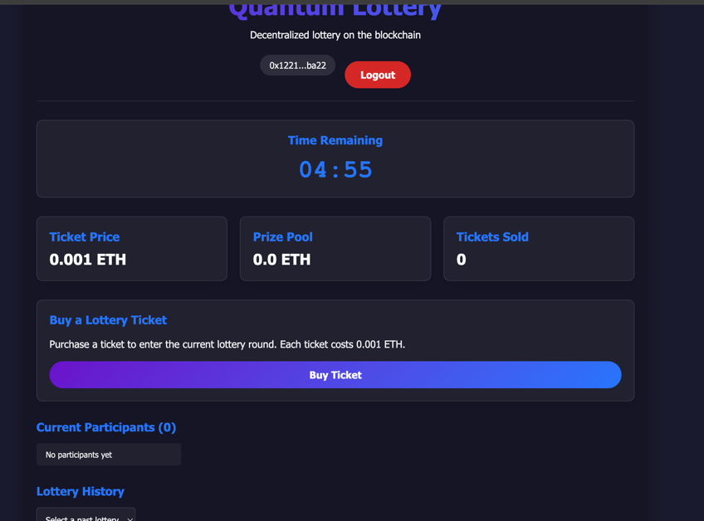
Figure 1: Main Lottery Interface with Active Countdown
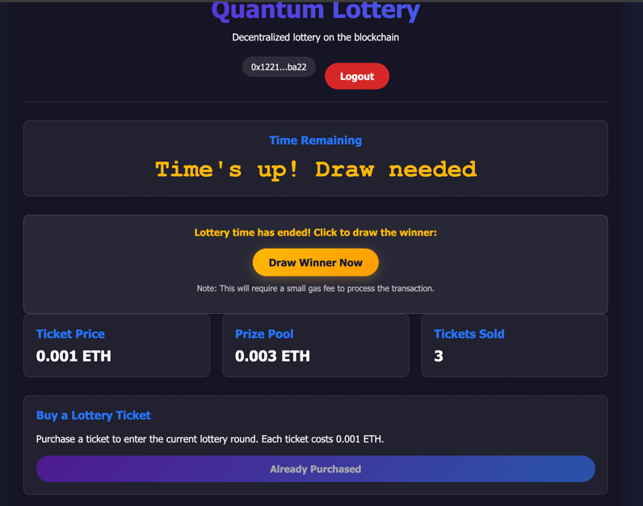
Figure 2: Main Lottery Interface when time is up

User Roles and Permissions
The application supports two distinct user roles:
- Regular Users:
  - Connect/disconnect wallet
  - Purchase tickets
  - View lottery information
  - Draw winner when lottery time expires
  - View lottery history
- Manager (Contract Owner):
  - All regular user capabilities
  - Draw winner
  - Force close lottery round
  - Access to special manager controls
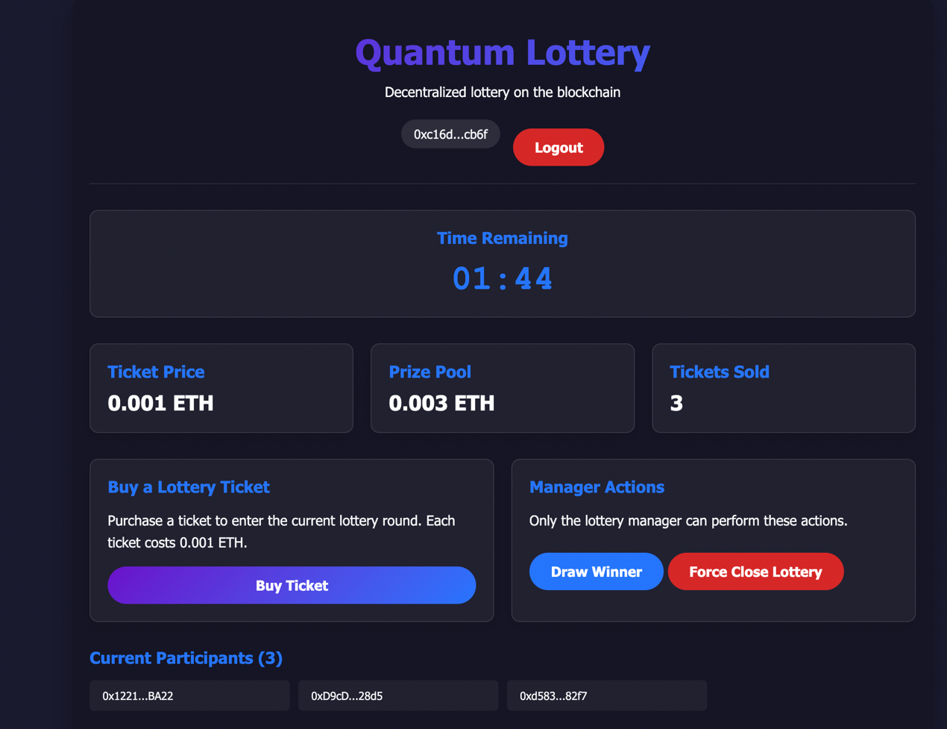
Figure 3: Manager Actions Panel

User Interface Components
The interface provides intuitive access to all lottery functions:
- Connection Panel:
  - Wallet connect/disconnect
  - Connected address display
  - Network status
- Lottery Information:
  - Real-time countdown timer
  - Ticket price display
  - Current prize pool
  - Tickets sold counter
- Action Area:
  - Ticket purchase button
  - Winner drawing interface
  - Manager-specific controls
- Participants List:
  - Current lottery participants
  - Highlighting for current user
- History Section:
  - Dropdown for past lottery selection
  - Winner and prize details
  - Timestamp of completion
  - Participants with winner highlighting
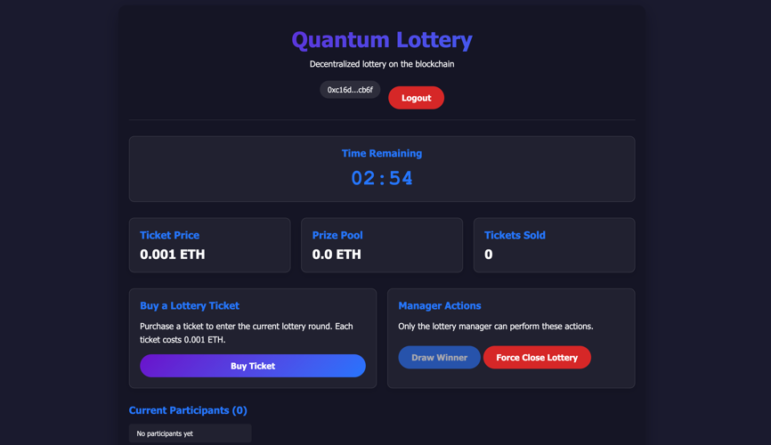
Figure 4: Full picture of the website

Implementation Details

Smart Contract Design
The QuantumLottery.sol contract implements several key design patterns:
- Time-Based State Management:
  - Uses timestamps instead of boolean flags
  - State determined by time relations:
function isLotteryActive() public view returns (bool) {
return block.timestamp < lotteryEndTime - END_THRESHOLD &&
ticketsSold < MAX_TICKETS;
}
- Enhanced Randomness:
  - Multiple entropy sources combined:
bytes32 entropy = keccak256(abi.encodePacked(
block.prevrandao,
block.timestamp,
block.coinbase,
ticketsSold,
reason
));
- Automatic State Transitions:
  - Multiple trigger conditions for drawing:
// Triggered on maximum tickets
if (ticketsSold == MAX_TICKETS) {
_drawWinner("Maximum participants reached");
}

// Triggered on time expiry
function checkAndDraw() external {
require(block.timestamp >= lotteryEndTime, "Cannot draw before lottery end time");
// Drawing logic...
}
- Clean Reset Functions:
  - Complete state reset between rounds:
function _startNewLottery() private {
lotteryId++;
ticketsSold = 0;
prizePool = 0;
lotteryEndTime = block.timestamp + LOTTERY_DURATION;

// Reset participant data
for (uint i = 0; i < participantList.length; i++) {
participants[participantList[i]] = false;
}
delete participantList;

emit LotteryStarted(lotteryId, lotteryEndTime);
}

Front-End Architecture
The front-end implementation focuses on efficiency and user experience:
- Local Time Calculations:
  - Minimizes blockchain calls by calculating time locally:
function updateLocalCountdown() {
const currentTime = Math.floor(Date.now() / 1000);
let remainingTime = lotteryEndTimeLocal - currentTime;
remainingTime = Math.max(0, remainingTime);
// Update UI with formatted time...
}
- State Synchronization:
  - Periodic checks to ensure UI reflects blockchain state:
// Update blockchain data periodically (every 15 seconds)
countdownInterval = setInterval(refreshLotteryData, 15000);
- Event-Driven Updates:
  - Real-time updates via contract events:
function setupEventListeners() {
lotteryContract.on('TicketPurchased', async (buyer) => {
// Update UI on ticket purchase
});

lotteryContract.on('WinnerSelected', async (winner, prize) => {
// Update UI on winner selection
});
// More event listeners...
}
- Responsive State Handling:
  - Dynamic UI adjustments based on lottery state:
async function handleTimeExpired() {
const participantsArray = await lotteryContract.getParticipants();
const hasParticipants = participantsArray.length > 0;

if (hasParticipants) {
// Show draw winner UI
} else {
// Show initialize new round UI
}
}

Security Considerations
The application implements multiple security measures:

Smart Contract Security
- Access Control:
  - Manager-only actions enforced via modifier:
  - modifier onlyManager() {
  - require(msg.sender == manager, "Only manager");
  - _;
  - }
- Input Validation:
  - Strict checking of all user inputs:
  - require(msg.value == ticketPrice, "Incorrect value");
  - require(!participants[msg.sender], "Already bought");
- Time Constraints:
  - Prevents actions outside allowed timeframes:
  - require(block.timestamp < lotteryEndTime, "Lottery time has expired");
  - require(block.timestamp < lotteryEndTime - END_THRESHOLD, "In final countdown period");
- Reentrancy Prevention:
  - State updates before external calls:
  - // State is updated before transferring funds to winner
  - _recordResult(winner, prize);
  - _startNewLottery();
  - // Only then transfer funds

Front-End Security
- Transaction Protection:
  - Button disabling during transactions:
  - buyTicketBtn.disabled = true;
  - // Transaction processing...
  - buyTicketBtn.disabled = false;
- Error Handling:
  - Comprehensive error capture and display:
  - try {
  - // Transaction code...
  - } catch (error) {
  - console.error('Error buying ticket:', error);
  - if (error.data?.message) {
  - showNotification(`Error: ${error.data.message}`, 'error');
  - } else if (error.message) {
  - showNotification(`Error: ${error.message}`, 'error');
  - } else {
  - showNotification('Error buying ticket. Please try again.', 'error');
  - }
  - }
- Connection Management:
  - Proper handling of wallet connections:
  - ethereum.on('accountsChanged', handleAccountsChanged);
  - ethereum.on('chainChanged', () => {
  - window.location.reload();
  - });

Testing Process and Results

Accounts within one wallet can be switched via Metamask extension in Chrome

Please reload once the account is changed

Test Scenarios

Test Case 1: Wallet Connection
- Steps:
  - Open application
  - Click "Connect Wallet"
  - Approve MetaMask connection
- Expected Result:
  - Address displayed in UI
  - Lottery information loaded
  - Buy ticket button enabled
- Actual Result:
  - Connection successful
  - Address properly displayed and truncated
  - All lottery data loaded correctly
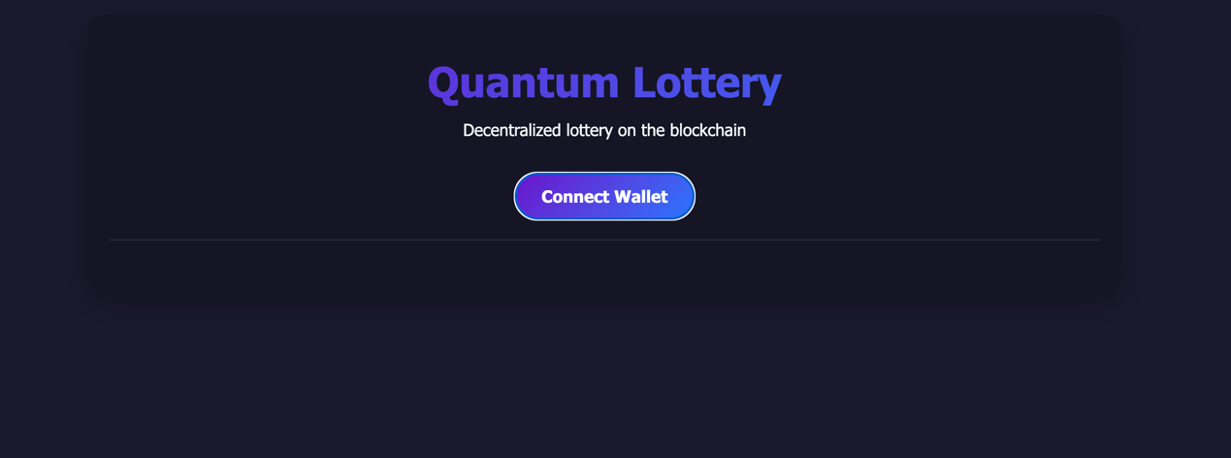
Figure 5: Button for account connection
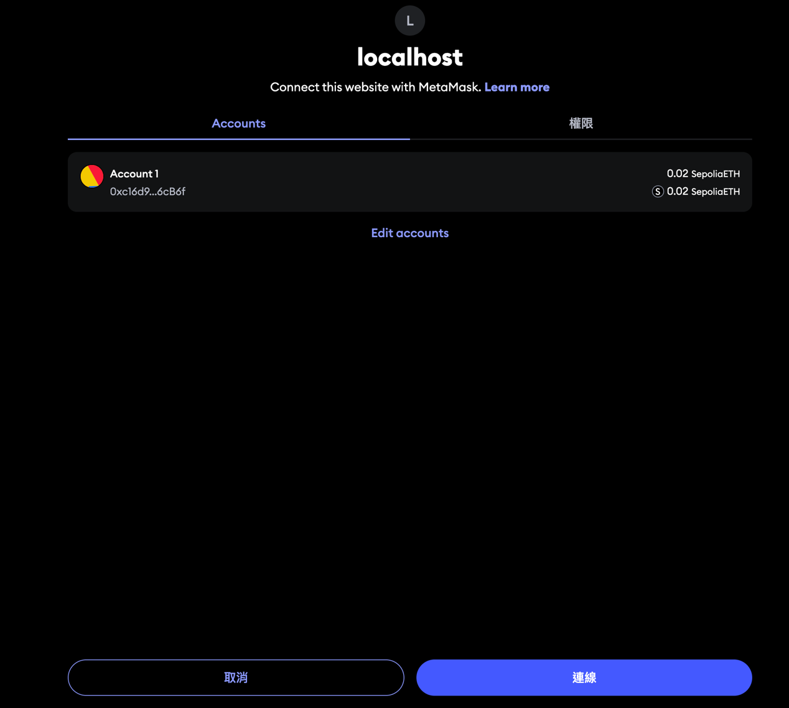
Figure 6: Selcet account

Test Case 2: Ticket Purchase
- Steps:
  - Connect wallet
  - Click "Buy Ticket"
  - Confirm transaction in MetaMask
- Expected Result:
  - Transaction processes
  - Ticket purchase confirmed
  - User appears in participants list
  - Buy button changes to "Already Purchased"
- Actual Result:
  - Transaction successful
  - Notification shows confirmation
  - User appears in participant list with highlight
  - Button state correctly changes
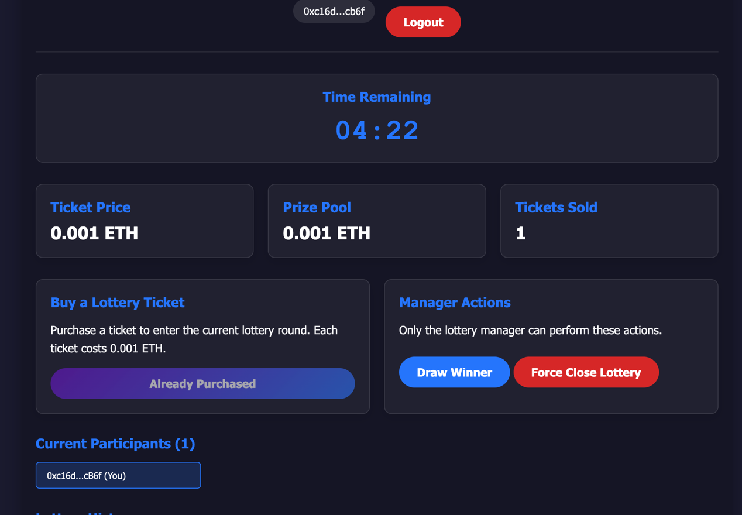
Figure 6: Ticket Purchase Interface with Status Update

Test Case 3: Multiple User Participation
- Steps:
  - Connect with three different accounts
  - Purchase ticket with each account
- Expected Result:
  - All purchases successful
  - Three participants shown in list
  - Prize pool increased to 0.003 ETH
- Actual Result:
  - All purchases completed
  - Three participants visible
  - Prize pool shows correct amount

Test Case 4: Time Expiry and Winner Drawing
- Steps:
  - Wait for lottery time to expire
  - Click "Draw Winner" button
  - Confirm transaction
- Expected Result:
  - Winner selected from participants
  - Prize transferred to winner
  - New lottery round started
- Actual Result:
  - Winner successfully selected
  - Transaction completed
  - Prize transferred correctly
  - New round initialized
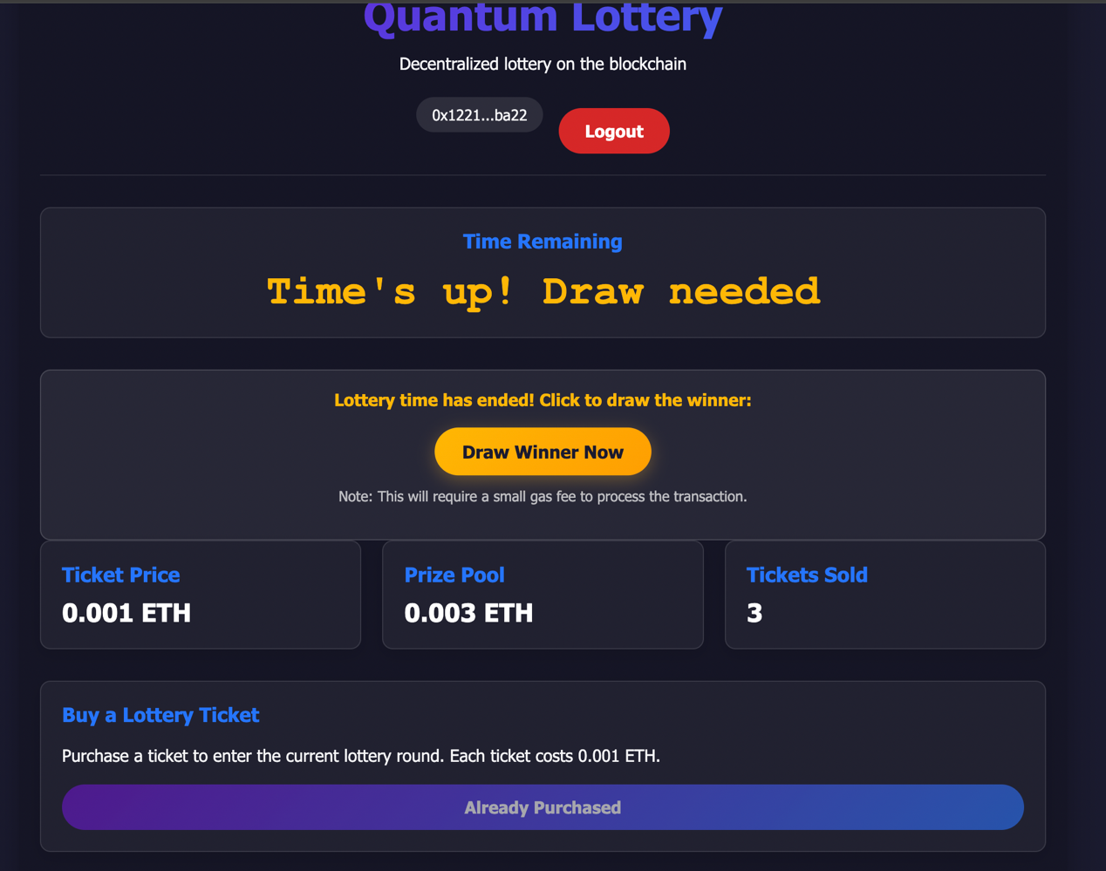
Figure 7: Lottery Drawing Interface with Time Expired

Test Case 5: Lottery History
- Steps:
  - Complete a lottery round
  - Select previous lottery from dropdown
- Expected Result:
  - Previous lottery details shown
  - Winner highlighted
  - Prize amount displayed
  - Participants list populated
- Actual Result:
  - History displayed correctly
  - Winner highlighted in green
  - Correct prize amount shown
  - All participants listed properly
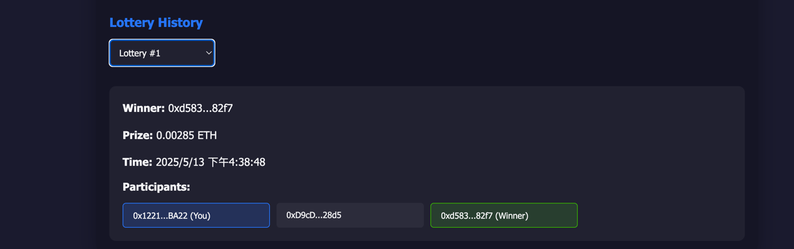
Figure 8: Lottery History View with Winner Highlighting

Test Case 6: Manager Functions
- Steps:
  - Connect with manager account
  - Verify manager actions visible
  - Test force close function
- Expected Result:
  - Manager actions visible
  - Force close resets lottery
  - New round starts immediately
- Actual Result:
  - Manager actions displayed
  - Force close functions correctly
  - New round initialized properly

Security Testing
- Threshold Period Test:
  - Attempted to buy ticket in last 10 seconds
  - Transaction properly rejected
  - Button disabled during threshold period
- Double Purchase Test:
  - Attempted to buy second ticket with same account
  - Contract rejected transaction
  - UI showed "Already Purchased" status
- Invalid Value Test:
  - Attempted to send incorrect ETH amount
  - Transaction rejected with proper error
  - UI showed detailed error notification
- Permission Test ( Via Remix ):
  - Attempted manager functions from non-manager account
  - Functions properly restricted
  - Error message displayed correctly

Challenges and Solutions

Challenge 1: Time Synchronization
Problem: Blockchain time can differ from local browser time, causing UI discrepancies.
Solution: Implemented a hybrid approach:
- Get lottery end time from blockchain once
- Calculate remaining time locally
- Periodic refreshes to realign with blockchain time
async function getLotteryEndTime() {
const endTimeBI = await lotteryContract.lotteryEndTime();
lotteryEndTimeLocal = Number(endTimeBI);
// Start local countdown with this anchor point
localCountdownInterval = setInterval(updateLocalCountdown, 1000);
}

Challenge 2: Transaction Congestion
Problem: Multiple users attempting to draw winner simultaneously could cause transaction failures.
Solution: Implemented UI state locking and clear visual feedback:
// Prevent concurrent draws
if (isDrawingInProgress) return;
isDrawingInProgress = true;

// Visual feedback
publicDrawLoader.classList.add('show-loader');
publicDrawButton.disabled = true;

Challenge 3: Enhanced Randomness
Problem: Basic blockchain randomness can be predictable or manipulated.
Solution: Used multiple entropy sources and added variability:
bytes32 entropy = keccak256(abi.encodePacked(
block.prevrandao,
block.timestamp,
block.coinbase,
ticketsSold,
reason
));
Figure 11: Empty Round Interface with New Round Option
Empty Round Interface with New Round Option

Contract Code Analysis
The QuantumLottery.sol contract serves as the backbone of the application. Below are key sections with detailed explanations:

Core State Variables
address public manager;
uint public ticketPrice = 0.001 ether; // Reduced price for testing
uint public constant MAX_TICKETS = 100;
uint public constant LOTTERY_DURATION = 5 minutes; // Each lottery lasts 5 minutes
uint public constant END_THRESHOLD = 10 seconds; // 10-second buying threshold

uint public prizePool;
uint public lotteryId;
uint public ticketsSold;
uint public lotteryEndTime; // When this lottery round ends
These state variables establish the fundamental parameters of the lottery system. The design uses a fixed ticket price (0.001 ETH), a maximum ticket limit (100), and a time-based approach with a 5-minute duration for each round. The 10-second threshold period ensures sufficient time for the blockchain to process the final state before drawing.

Participant Tracking
// Current lottery participants
mapping(address => bool) public participants;
address[] public participantList;

// Lottery history tracking
struct LotteryResult {
address winner;
uint prize;
uint timestamp;
address[] participants;
}
mapping(uint => LotteryResult) public history;
The contract employs dual data structures for participant tracking: a mapping for efficient lookups (preventing duplicate ticket purchases) and an array for enumeration and winner selection. The history mapping stores complete lottery records, including winners, prizes, and all participants for each lottery ID.

Lottery Drawing Logic
function _drawWinner(string memory reason) internal {
// Improved randomness using multiple block properties
bytes32 entropy = keccak256(abi.encodePacked(
block.prevrandao,
block.timestamp,
block.coinbase,
ticketsSold,
reason
));

uint index = uint(entropy) % ticketsSold;
address winner = participantList[index];

// 95% to winner, 5% to manager
uint prize = prizePool * 95 / 100;
uint fee = prizePool - prize;

if (prize > 0) {
(bool success,) = winner.call{value: prize}("");
require(success, "Transfer failed");
}

if (fee > 0) {
payable(manager).transfer(fee);
}

emit WinnerSelected(winner, prize);
_recordResult(winner, prize);
_startNewLottery();
}
This critical function handles winner selection and prize distribution. The implementation focuses on:
- Enhanced randomness using multiple entropy sources
- Fair winner selection from participant list
- Splitting the prize pool (95% to winner, 5% to manager)
- Proper error handling for transfers
- Event emission for front-end notifications
- State recording and clean reset for the next round

Front-End Implementation Details

Event Handling System
function setupEventListeners() {
// Listen for ticket purchases
lotteryContract.on('TicketPurchased', async (buyer) => {
if (buyer.toLowerCase() === currentAccount.toLowerCase()) {
showNotification('Your ticket purchase was successful!', 'success');
}
await refreshUI();
});

// Listen for winner selection
lotteryContract.on('WinnerSelected', async (winner, prize) => {
const formattedPrize = formatUnits(prize, "ether");
const message = winner.toLowerCase() === currentAccount.toLowerCase()
? `Congratulations! You won ${formattedPrize} ETH!`
: `Winner selected! ${shortenAddress(winner)} won ${formattedPrize} ETH`;
showNotification(message, 'success');

// Reset local variables and refresh UI
isDrawingInProgress = false;
await refreshUI();
await getLotteryEndTime(); // Get the new lottery end time
});

// More events...
}
The front-end uses an event-driven architecture to maintain real-time synchronization with the blockchain. Each contract event triggers specific UI updates and user notifications, ensuring the application state remains consistent with the blockchain state without requiring constant polling.

Hybrid Time Calculation
async function getLotteryEndTime() {
const endTimeBI = await lotteryContract.lotteryEndTime();
lotteryEndTimeLocal = Number(endTimeBI);
console.log('Lottery end time:', lotteryEndTimeLocal);

// Update local countdown immediately
updateLocalCountdown();
}

function updateLocalCountdown() {
// Get current time
const currentTime = Math.floor(Date.now() / 1000);

// Calculate remaining time
let remainingTime = lotteryEndTimeLocal - currentTime;

// Ensure it's not negative
remainingTime = Math.max(0, remainingTime);

// Format the time
const minutes = Math.floor(remainingTime / 60);
const seconds = remainingTime % 60;

// Update countdown display
if (countdownDisplay) {
if (remainingTime > 0) {
const formattedTime = `${minutes.toString().padStart(2, '0')}:${seconds.toString().padStart(2, '0')}`;
countdownDisplay.textContent = formattedTime;
// UI updates...
} else {
// Handle time-up UI
handleTimeExpired();
}
}
}
This hybrid approach to time calculation significantly reduces blockchain calls while maintaining accuracy. The system:
- Gets the lottery end time from the blockchain once
- Uses local browser time for continuous countdown updates
- Periodically syncs with the blockchain to correct any drift
- Handles time expiry with custom UI states

Future Improvements
- Multi-Chain Support:
  - Expand to additional EVM-compatible networks
  - Implement chain detection and switching
- Variable Ticket Options:
  - Allow users to purchase multiple tickets
  - Implement tiered ticket pricing
- Enhanced Randomization:
  - Integrate with Chainlink VRF for provable randomness
  - Implement commit-reveal schemes for improved security
- Progressive Jackpot:
  - Carry over percentage of prize pool to next round
  - Implement minimum participant threshold for draws
- Social Features:
  - Winner leaderboard
  - Social sharing of results
  - Referral system with rewards

Conclusion
The Quantum Lottery DApp successfully implements a fully decentralized lottery system on the Ethereum blockchain. The application provides a secure, transparent, and user-friendly interface for participating in lottery rounds, with enhanced randomness features that improve fairness.
The project demonstrates several important blockchain development principles:
- Time-based state management
- Enhanced randomness techniques
- Efficient UI-blockchain synchronization
- Comprehensive error handling
- Proper access control implementation
The testing results confirm that all components work together seamlessly to provide a robust lottery experience. The application successfully balances on-chain security with off-chain user experience optimizations, resulting in a functional and responsive decentralized application.

